PRESS RELEASE dated 23/11/2021

Pulsar Photonics continues its growth path: opens new company location

- The laser technology specialist is tripling its production capacity with the addition of a new site
- Expansion ensures growth above all in the field of laser system construction

Herzogenrath, 23/11/2021: Pulsar Photonics is continuing on its growth path with its new plant in Aachen-Verlautenheide. The company's second plant triples the production capacity of the laser technology specialist from Herzogenrath and establishes the necessary preconditions to meet the demand in the fast-growing field of laser machine engineering. Choosing this location is a clear reflection of the importance of the Aachen city region for the laser technology industry, as ideal conditions can be found here due to the proximity to scientific institutions and the work in the "LASER.region.AACHEN" network.

High demand for production solutions
The demand for laser machines for the processes of laser drilling, ablation and cutting with ultrashort pulse lasers, but also with cw and QCW lasers (continuous wave and quasi-continuous wave lasers) has soared in recent years. There was particularly high demand for automated production solutions for laser micromachining from the industrial sectors of electronics, medical technology and process engineering. With its second plant, Pulsar Photonics is systematically expanding its manufacturing capacities to satisfy this demand in the field of laser system construction

Dr. Joachim Ryll, founder and managing director of Pulsar Photonics GmbH: "By opening this plant and expanding our production capacity, we are responding to the strong increase in demand for turnkey production machines and RDX laser machines over the past few years. The second plant will provide us with enough flexibility to expand our production space as the company continues to grow. At the same time, being part of the Schunk Group provides us with the foundation for further growth, which is especially important in times of uncertain supply chains. In addition, the opening of the plant has enabled us to gain a great new partner in Walbert & Schmitz for logistics, marketing and infrastructure."

A free-to-use photo of the new plant can be found at: www.pulsar-photonics.de/ueber-uns/presse-und-news/

Pulsar Photonics
Pulsar Photonics GmbH is an innovative high-tech company in the field of laser technology. Its range of services includes the development, production and distribution of laser machines for material processing with short and ultra-short pulse lasers. A second core competence of the company is the integration of tooling and measuring systems for material processing, adapted to the specific requirements of the application. Besides its expertise in system development, Pulsar Photonics is also a competent partner for single-part and series production with (ultra-)short pulse lasers. Its core processes focus on structuring, drilling and precision cutting.
Founded in 2013, Pulsar Photonics GmbH is one of the fastest growing companies in Europe, according to the Financial Times and Statista. Pulsar Photonics has been part of the Schunk Group since 2021.
For more information, visit www.pulsar-photonics.de

Images
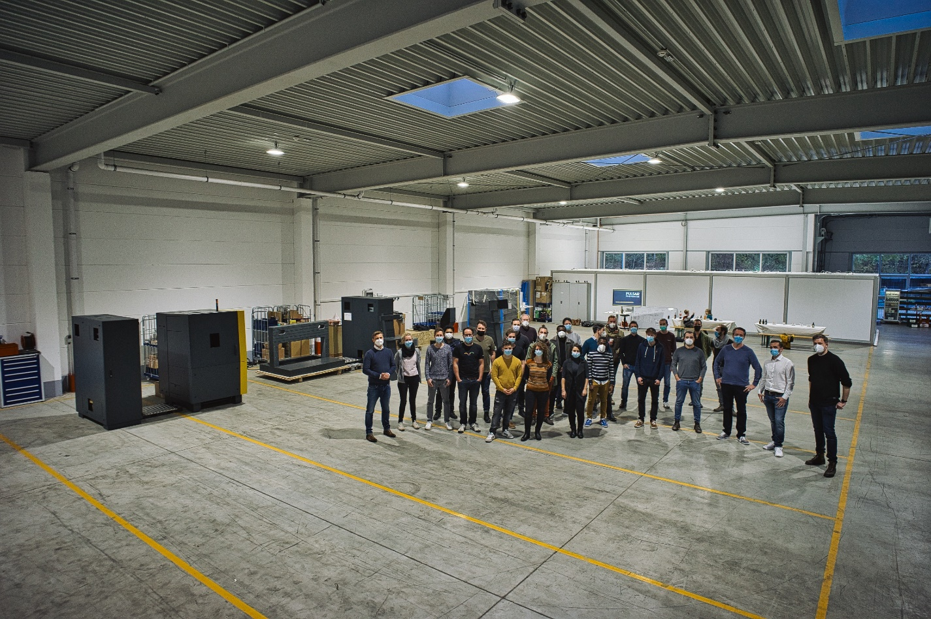

The second plant in Aachen-Verlautenheide triples Pulsar Photonics' manufacturing capacity (Source: Pulsar Photonics GmbH).

Press Contact
Pulsar Photonics GmbH
Dr. Stephan Eifel
Kaiserstraße 100
52134 Herzogenrath
Telephone: +49 (0) 2407 55 555 - 0
E-mail: info@pulsar-photonics.de
Website: www.pulsar-photonics.de

