27th November 2023
Pulsar Photonics GmbH
Kaiserstr. 100
52134 Herzogenrath
Germany

PRESS RELEASE
Contakt Information
Website | www.pulsar-photonics.de
Mail | info@pulsar-photonics.de
Telefon | +49 (0) 2407 55555-0

27th November 2023

New chapter at Pulsar Photonics: ground-breaking ceremony for the new headquarters in Aachen
Pulsar Photonics, machine builder and contract manufacturer in the field of laser technology, is taking a significant step in its corporate development next year. With the infrastructure partner Walbert-Schmitz GmbH & Co. KG and a seven-figure investment, the ground-breaking ceremony for the new headquarters in Aachen has now taken place. This decision not only reflects practical growth, but will also further improve the company's visibility.

From Fraunhofer ILT to future location: development since 2013
Pulsar's history began in 2013 on the premises of the Fraunhofer Institute for Laser Technology ILT. In 2015, the company moved to the Technologiepark Herzogenrath (TPH), which became the headquarters from then on. As the number of employees grew, new premises were needed - initially in the TPH. Then from 2022 with another manufacturing hall in Aachen: Ideal conditions for the laser machine construction team.
Manufacturing hall 3 for system technology followed a year later. "With Hall 4, which we will be moving into this year, our workspace now extends to more than 4,500 impressive square meters," summarizes Dr. Joachim Ryll, one of the three Managing Directors.
10 years after the company was founded, the next major milestone is now set to follow: the business divisions will be brought together at one location one after the other and the headquarters will also be relocated from Herzogenrath to Aachen. The ground-breaking ceremony for this final step took place a few weeks ago.

Creating an attractive workspace
The new location at the Verlautenheide highway exit not only offers the urgently needed reserves for future growth, but also makes it possible for the first time to create space before acute demand arises.
Another decisive aspect, however, is the consolidation of the business divisions at a joint location. No longer separated locally, the interaction between the various divisions will be strengthened. "This spatial proximity should not only shorten transport routes again, but above all intensify cooperation and the exchange of information between the teams," the management agrees.
"We not only want to be attractive for staff due to the convenient connections, but also take into account all aspects of a workspace in a modern and pleasant atmosphere," says Ryll. "From home office to office home" is how Burkhardt Mohns, Managing Partner at W-S, likes to describe this development.
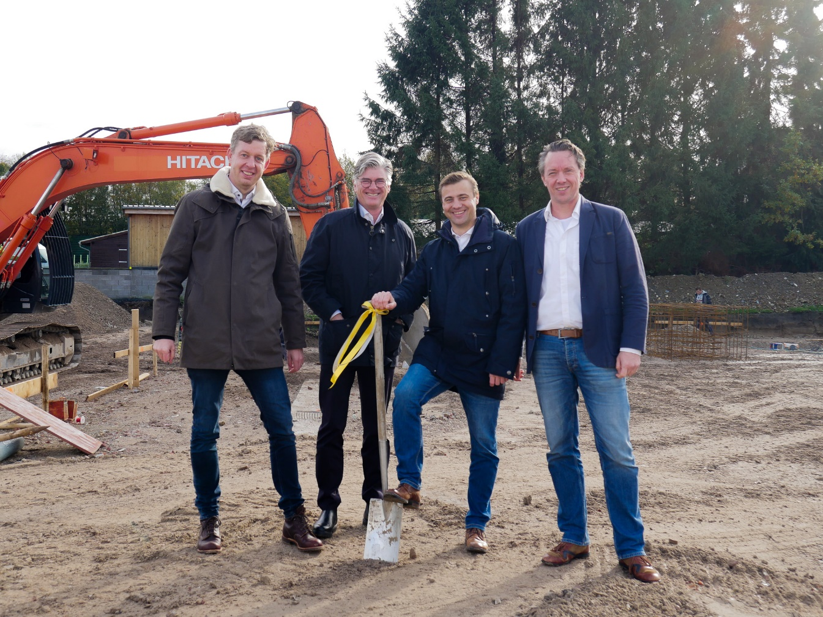
Picture 1: With Walbert-Schmitz GmbH & Co. KG, Pulsar Photonics has had a professional partner and lessor at its side since 2021. Pictured here from left to right: Dr. Stephan Eifel, Burkhardt Mohns (W-S), Dr. Joachim Ryll, Dr. Jens Holtkamp on the site of the new headquarters in Aachen.
Space for sustainable growth prospects
Pulsar Photonics wants to grow spatially, but also create the basis for a modern and future-oriented working environment. The focus on modern working methods and technologies should make it possible to operate more flexibly and efficiently. This includes not only the design of the workspaces, but also the technological and digital infrastructure such as the expansion of fiber optic networks, the networking between the teams or the implementation of modern in-house IT.
At the same time, measures are planned to pave the way for a sustainable and energy-efficient orientation of the company. This includes the availability of space for the use of renewable energy sources such as solar or the provision of larger parking spaces for bicycles and electric cars. The planned building is a so-called KfW building and therefore meets certain energy standards. These include the use of CO2-reduced building components, a green roof, heating by heat pump and photovoltaic systems to secure the power supply. Prospects that are due in particular to the infrastructure partner. However, the current operation is also ensured by the real availability of larger electrical connection cross-sections for machine operation.
Improved visibility in a favorable position
The excellent highway connection at Aachener Kreuz not only makes mobility easier for employees, it also offers an important logistical advantage for customers, suppliers and service providers. "Our aim is to become even more visible as a laser company in the region," says Ryll. "To this end, the new headquarters will be designed to be representative."
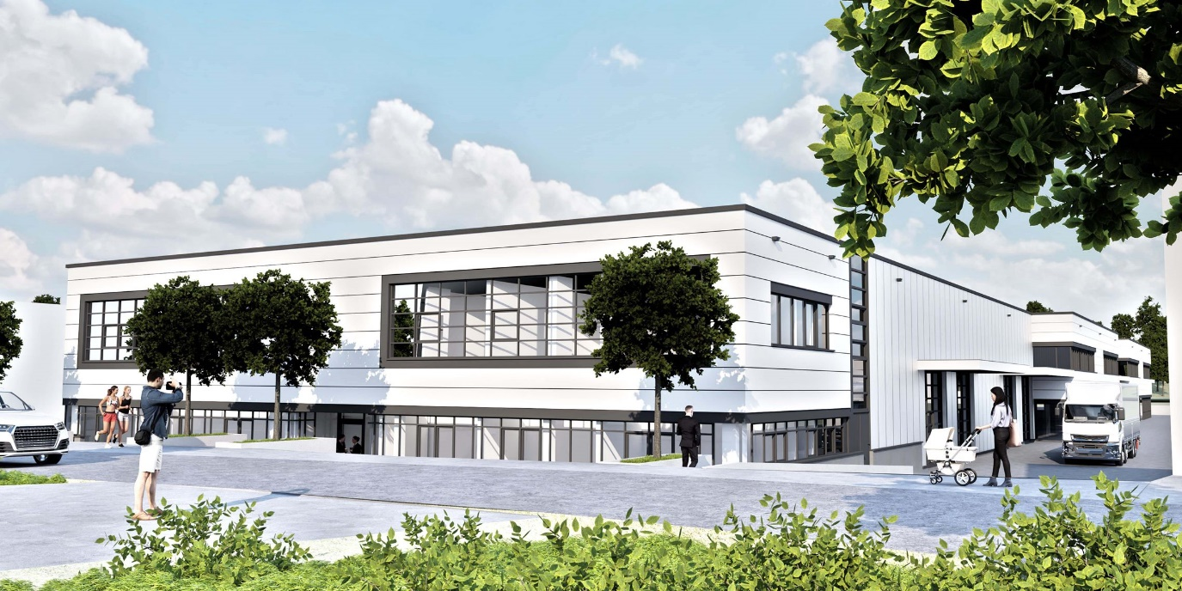
Picture 2: Construction plan for the new Pulsar headquarters: the new building complex is scheduled for completion at the end of 2024 and will offer all the prerequisites for a sustainable and attractive workplace.

Contribution to positive structural change
"We are delighted to be able to make a contribution to positive structural change with this location decision. Not least by creating jobs, the alliance partners in the laser region are helping to shape the future prospects in Aachen and the surrounding area in a sustainable way," explains Ryll.
A seven-figure investment is being made to construct the new building, which will later be used primarily for assembly and production. With a work and manufacturing area of around 1,600 square meters, the first construction phase of the new building should be completed and ready to move into by the end of 2024. The three-member management team is looking positively to the next 10 years. "With the additional building, we want to create a platform that takes our corporate culture, creativity and regional collaboration to a new level. Healthy, profitable and sustainable growth is important to us - both in the past and today," says Joachim Ryll.

Pulsar Photonics
Pulsar Photonics GmbH is an innovative high-tech company in the field of laser technology. The company's range of services includes laser process technology, machine manufacturing with software development and the laser systems technology division.
Since its foundation, the company has been working intensively on scaling approaches for production. For customers, the company offers exclusive services ranging from professional application development and ramp-up to the construction of automatic production machines with service and know-how transfer. Pulsar Photonics is continuously investing in its own production capacities for single part and series production with (ultra) short pulse lasers. The core processes are structuring, drilling and precision cutting.
Pulsar Photonics GmbH has its headquarters in Aachen-Herzogenrath and operates two further manufacturing halls in Aachen-Verlautenheide. The company was founded in 2013 as a spin-off of the Fraunhofer ILT in Aachen and was financed in its growth phase by the Hightech Gründerfonds HTGF, Bonn. Pulsar Photonics has been part of the Schunk Group since 2021.
With more than 90 employees today, the fast-growing and profitable company is a German SME and part of the LaserRegionAachen structural change initiative.
Further information can be found at www.pulsar-photonics.de/en/.
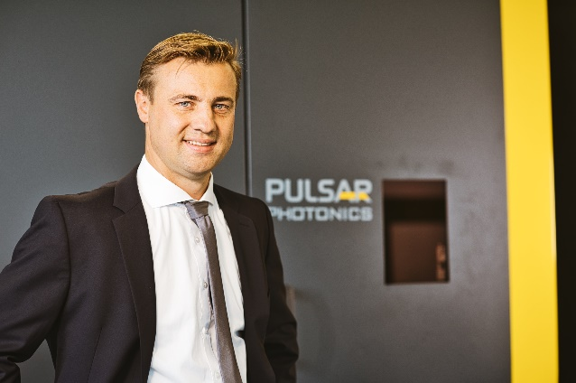
Contact Person  Dr. Joachim Ryll, Managing Director  Pulsar Photonics GmbH  Kaiserstraße 100  52134 Herzogenrath  Phone: +49 2407 55 555 - 22  E-Mail: ryll@pulsar-photonics.de | Press Contact  Sonja Wichert, M.A.  Pulsar Photonics GmbH  Kaiserstraße 100  52134 Herzogenrath  Phone: +49 2407 55 555 - 11  E-Mail: wichert@pulsar-photonics.de

